Student Name: __________________
Class and Section __________________
Total Points (20 pts) __________________
Due: March 21, 2011 before the class

Project: Mutli-Thread Server

CSCI 5520 Rapid Java Application Development
Armstrong Atlantic State University

Problem Description:

Loan server) Write a server for multiple clients. The client sends loan information (annual interest rate, number of years, and loan amount) to the server (see Figure 30.21(b)). The server computes monthly payment and total payment and sends them back to the client (see Figure 30.21(a)). Name the client Exercise30_1Client and the server Exercise30_1Server.

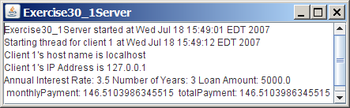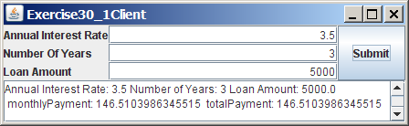
(a) (b)

Figure 30.21
The client in (b) sends the annual interest rate, number of years, and loan amount to the server and receives the monthly payment and total payment from the server in (a).

Source code:

Two .java files named PExercise31_01Server.java and PExercise31_01Client.java

Screen shot:

What to submit?

- This document.
- Save/Compile and Submit to two .java file on LiveLab.

2. Fill in self-evaluation:

For Server
- Can you create the UI correctly? _________
- Can your server accept multiple clients? ______
- Can your server perform computation correctly? _______________

For Clients
- Can you create the UI correctly? _________
- Can your client connect to the server? ______
- Can your client send data to the server? _______________
- Can your client receive data from the server? _______________

